# CS 255 System Design Document

## UML Diagrams

### UML Use Case Diagram

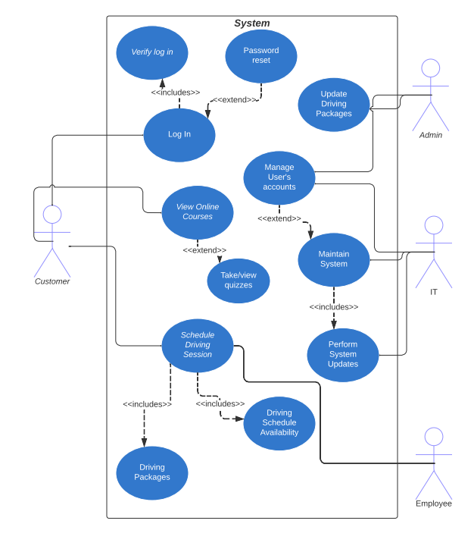

### UML Activity Diagrams

*[You were asked to choose* ***two*** *use cases and create* ***two*** *activity diagrams, one for each use case. Please insert* ***both*** *of your activity diagrams here. Check to make sure that you included appropriate components and symbols and that your design meets the client’s needs.]*

### UML Sequence Diagram

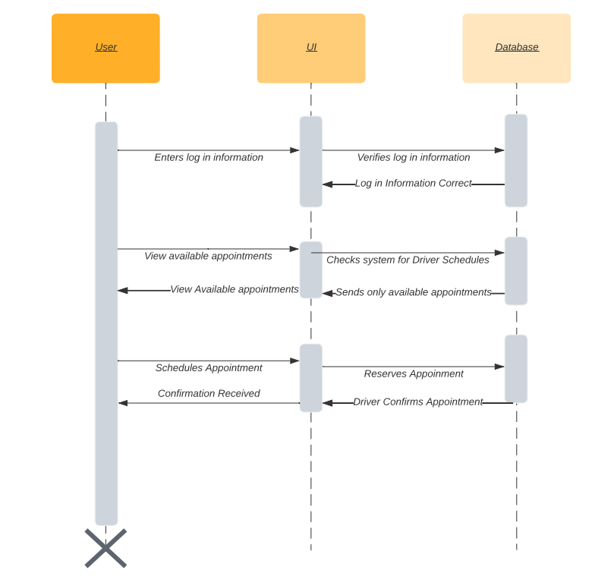

### UML Class Diagram

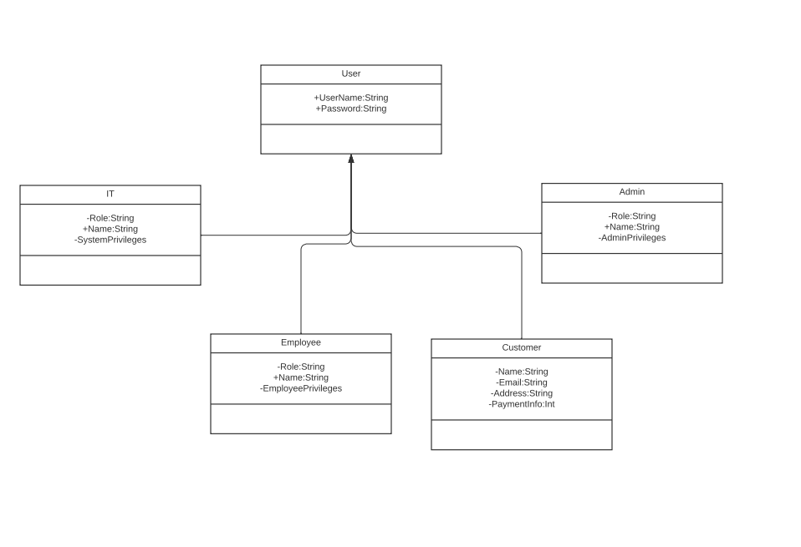

## Technical Requirements

DriverPass would like its system to be web-based. It needs to be available and compatible on multiple platforms, including mobile. The system should also be easy to update, as DriverPass plans to update its packages and would like to update any changes the DMV makes. Customers should have the ability to reset their passwords on their own. However, DriverPass would like their secretary to establish an online account for the customer, whether over the phone or in person. The system must allow the secretary to create customer accounts, allow the administrator to download reports offline, allow the administrator to track changes made, let the administrator enable and disable accounts for customers and employees, and allow their IT to update the system quickly. The program should be cloud-based and must be encrypted for additional security. The design needs to be able to handle customer traffic. The database should allow user information to be stored and accessed when the user logs into their account. The system should inform the administrator of a problem immediately. The administrator should be able to make changes based on the business needs. There should be a multifactor authentication when the user logs in.